OTEC Communication Company
245 W Third St., PO Box 427
Ottoville, OH 45876
Telephone: 866-363-9211
Email: webmaster@otecwb.com

Your Subscriber Portal:
A User Guide

Experience the Subscriber Portal 2
Log into the Portal 2
Review Your Account Information 2
Strengthen Your Password 3
Choose Who Can and Cannot E-mail You 3
Set Your Spam Defense 4
Evaluate Your Spam Filter Settings 6
Monitor Your WildBlue Usage 6
Consolidate E-mail Accounts and Take a Vacation 6
Forward Messages 7
Set Auto-Reply 7
Limit Dial-up Access to the Internet 7
Build Your Own Web Site 8
Manage Your Mailbox Size 9
Choose Additional Applications 9
Add Additional Users 10
Set Mailbox Size for Additional Users 11

Experience the Subscriber Portal
Thank you for being a subscriber. We are pleased to offer you this new Subscriber Portal, which replaces the “AdminTool.” We believe the Subscriber Portal will improve your ability to manage your account.

Log into the Portal
Your new URL is admintool.otecwb.com. Please bookmark it!

If you have logged into the AdminTool previously, your username and password will be the same for the Subscriber Portal. If you do not know your username and/or password, contact us at 866-363-9211. Note that the system times out after two hours of non-use and you will need to log in again.

As you explore the Subscriber Portal, we hope this guide and the instructions in the Help tabs will come in handy. But, again, if you have any trouble, please contact us at 866-363-9211.

Review Your Account Information
When you log into the Subscriber Portal, you will see the “Summary” page that contains your account information. Please let us know if any of the information is incorrect!

If you are the “Owner” of the account—that is, if the account is in your name and you are responsible for the bills, here are a few things to do on the Summary page:
- Write down our domain. You'll need it if you want to create your own Web site using the free, easy-to-use software program, Site Creator.
- Confirm that we have your current billing and service addresses.
- Check your Mailbox Size to see how much space you have available. (The owner is listed as "User 1" in the account.)
- Confirm whether your Auto-Reply is on and scan your Auto-Reply message for typos.
- Review who is in your Friends Circle and on your Black List.
- See how much space you have left on your personal Web site (Vanity Page), if you are using your Web Page Service.
- View the information that the other people on your account (identified in the system as “Users”) have submitted and check how much space they have available in their mailboxes.

If you are not the owner of the account:
- Check your Mailbox Size to see how much space you have available. (The owner is listed as "User 1" in the account.)
- Confirm whether your Auto-Reply is on and scan your Auto-Reply message for typos.
- Review who is in your Friends Circle and on your Black List.
- View your login time to see what days and times you can log in, if you have dial service and the owner of the account has set parameters.
- See how much space you have available on your personal Web site (Vanity Page), if you are using your Web Page Service.

Strengthen Your Password
Don’t let yourself be victimized by cyberscammers. Cyberscammers try to infiltrate e-mail accounts that have weak passwords and send out spam and set up phishing scams from those accounts. (Phishing sites are those pretend sites that try to get personal information from you.) Protect your identity and your money by strengthening your password!

To change your password and view its strength, go to the “Manage User” tab and the “Information” sub-tab.

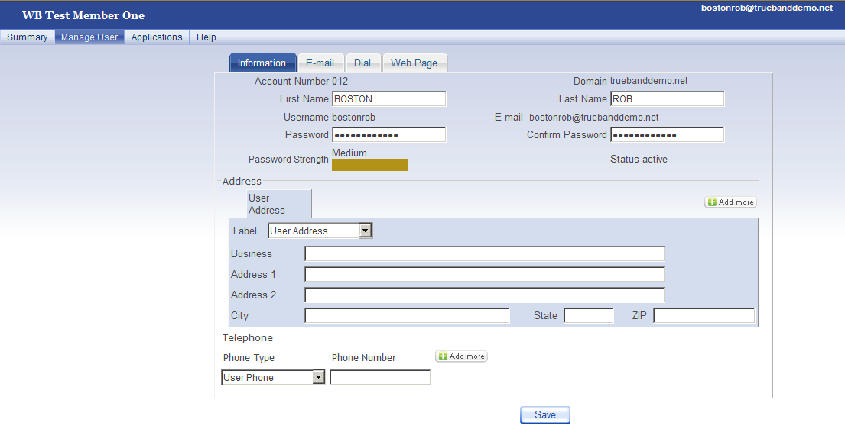
1
2
Choose a password (Arrow #1) that contains the following:

- At least eight characters
- Lower and upper case letters
- Numbers
- A symbol (!)

There are eight categories that range from “Not allowed” to “Strongest.” Try to create a password that receives at least a "Strong" rating on the Password Strength Meter (Arrow #2).

Choose Who Can and Cannot E-mail You
Aren’t you sick of spam? Although we block most spam messages, you can reduce the number even more. Go to the “Manage User” tab and the “E-mail” sub-tab to create a Friends Circle and Black List.

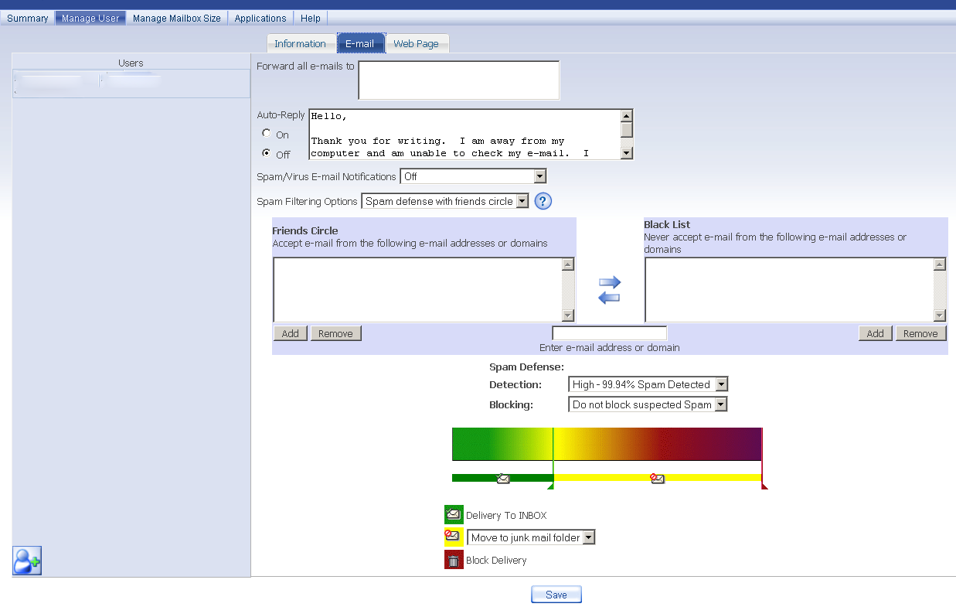
1
2

In the drop-down box next to “Spam Filtering Options” (Arrow #1), choose between the following three settings:
- Spam Defense with Friends Circle – This is the default option. It incorporates your Friends Circle and Black List information so that your friends' e-mails get through, but spam is blocked.
- Friends Circle Only – With this setting, you only receive e-mails from the addresses or domains you designate.
- Friends Circle with Confirmation – With this setting, if people outside of your Friends Circle send you an e-mail, they will get an automatic reply asking them to prove that they are human (and not a computer). For instance, they might have to identify what is in a picture. Once they do this, you will receive their e-mail. This setting prevents automated systems from sending you e-mails.

Populate your Friends Circle and Black List by adding information into the “Enter e-mail address or domain” box and clicking the appropriate “Add” or “Remove” buttons (Arrow #2). When entering domains, begin with the "@" symbol; for example, “@google.com.”

Set Your Spam Defense
Control how much spam you get using new tools highlighted in the following screenshot.

1
2
3
4

Use the drop-down “Detection” and “Blocking” menus (Arrow #1) to determine how much spam you receive. The higher you set the detection level, the more rigorously the network will scan your incoming messages and identify those it suspects are spam. Then, with the “Blocking” drop-down menu, you can decide what to do with those messages that the network suspects are spam—block them outright, block most of them, etc. Please note: Blocked messages are not recoverable!

If you prefer to fine-tune your settings, you can use the slider (Arrow #2) instead of the dropdown menus. Here are a few hints:
- The farther you drag the green slider to the right, the more spam messages you will receive.
- The farther you drag the red slider to the left, the more spam messages will be blocked.
- The greater distance you leave between the green and red sliders, the more spam messages will either appear with a subject flag with the name of your choosing or sent to your junk mail folder.

Decide where you want spam/junk mail to go (Arrow #3):
- Delivery to Inbox – All of your e-mails will arrive in your inbox, including spam.
- Set Your Subject Flag To – The e-mails that your ISP suspects are spam will have a flag in the heading. In this box, you type in the subject heading for these messages. If you click on the down arrow next to "Set your subject flag to," you get the option to "Move to junk mail folder." This way, the e-mails your ISP suspects to be spam will be delivered directly to your junk mail folder, not your inbox.
- Block Delivery – The messages that your ISP suspects to be spam will not be delivered.

Evaluate Your Spam Filter Settings
If you turn the Spam/Virus E-mail Notifications on (Arrow #4), you will see how well your spam filter settings are working. You can make adjustments at any time.

Monitor Your WildBlue Usage
If you have WildBlue Satellite Internet service (and you are the owner of the account), you can perform the following tasks.

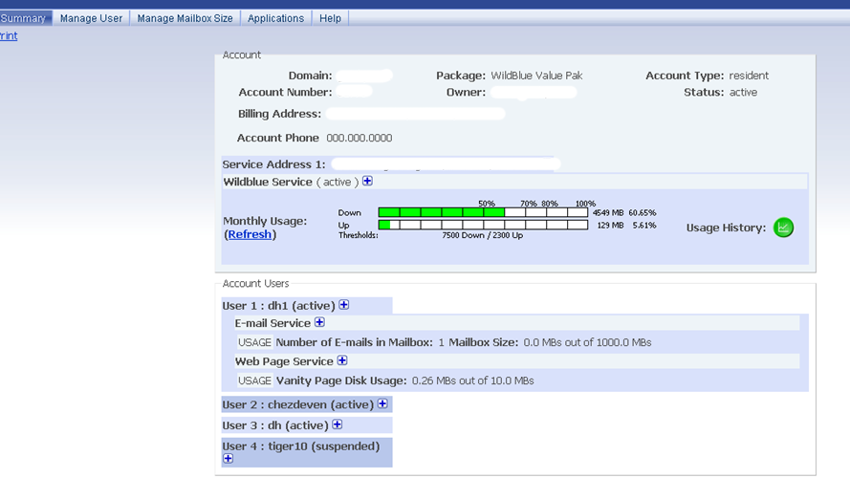
1
2
- View your WildBlue usage graphs to make sure that the average amount of data you download and upload within a rolling 30-day period is compliant with WildBlue's Fair Access Policy (FAP), found on WildBlue’s Web site: http://wildblue.com/. As long as the graph is green, you are in compliance. If you see yellow, you are getting close to your usage threshold. And if you see red, you are not in compliance with WildBlue’s FAP. (Arrow #1)
- Click on the "Usage History" icon to view your WildBlue usage statistics over previous months. (Arrow #2)
- If you call us with questions about your WildBlue service, share details about your installation, including your MAC Address, Cable Length, Modem Serial Number and Beam Number.

Consolidate E-mail Accounts and Take a Vacation
Balancing multiple e-mail accounts? Need an e-mail holiday? Go to the “Manage User” tab, “E-mail” sub-tab. (This is the same screen that contains the spam filter options.)

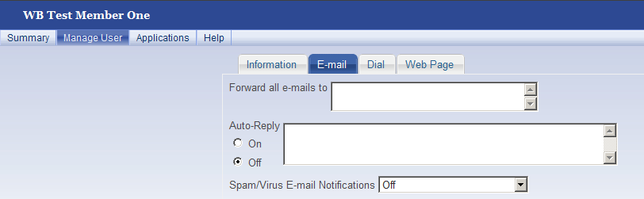
1
2

Forward Messages
If you want to forward your e-mails to a different account, type that e-mail address in this box (Arrow #1).

Set Auto-Reply
If you know you will not be answering e-mails for a certain period of time, turn on the Auto-Reply and type a message into the box that lets people know when you will be answering e-mails again (Arrow #2). To turn off the Auto-Reply, select "Off."

Limit Dial-up Access to the Internet
Choose the days and times you and the users on your account can access e-mail and the Internet. Maybe you are a parent and want your children only to surf the Internet from 6 to 8 p.m. on weekdays and from noon to 2 p.m. on weekends. Go to the “Manage User” tab, “Dial” sub-tab. The following screenshot shows how to enter these parameters. (The time corresponds to your local time zone.) If you leave this page blank, access to the Internet will not be restricted.

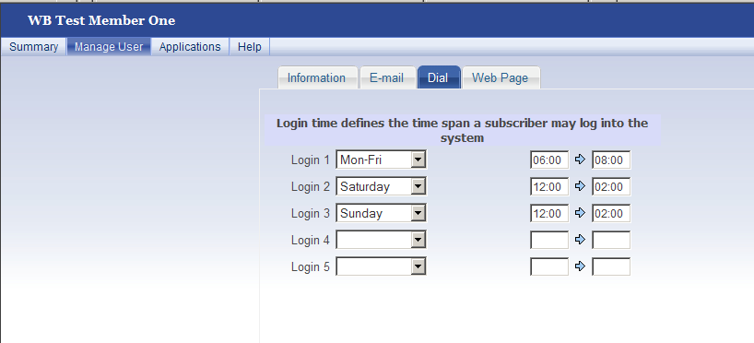

Build Your Own Web Site
With the tools that we provide, it’s easy to build your own Web site. Go to the “Manage User” tab and click on the “Web Page” sub-tab.

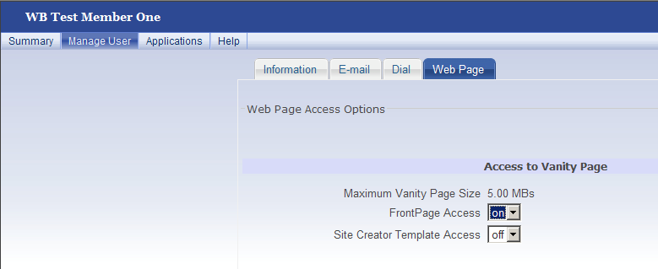

FrontPage, by Microsoft, is an HTML editor and Web site administration tool. If you create a Web site using FrontPage, turn the “FrontPage Access” to "on" using the drop-down menu. We support FrontPage versions up to and including FrontPage 2000.

Site Creator is a software program that helps you build your own Web site using easy, step-by-step instructions and templates. To use Site Creator:

- Turn “Site Creator Template Access” to “on” using the drop-down menu.
- Open a new browser with the URL: "http://sitecreator.MEMBERDOMAIN." (Type in our domain name, don't type in "MEMBERDOMAIN" or the quotation marks.)
- Use the same username and password for Site Creator that you used to log into this portal.
- If you have questions about using Site Creator, please call. We can send you the Site Creator User's Guide and answer additional questions.

Manage Your Mailbox Size
The owner of the account can control his or her mailbox size. Go to the “Manage Mailbox Size” tab to view current mail usage and click on the plus and minus signs (Arrow #1) to adjust the size of the mailbox. The single plus and minus signs increase/decrease the size by one Megabyte (MB). The double plus/minus signs increase/decrease the size by ten MBs.

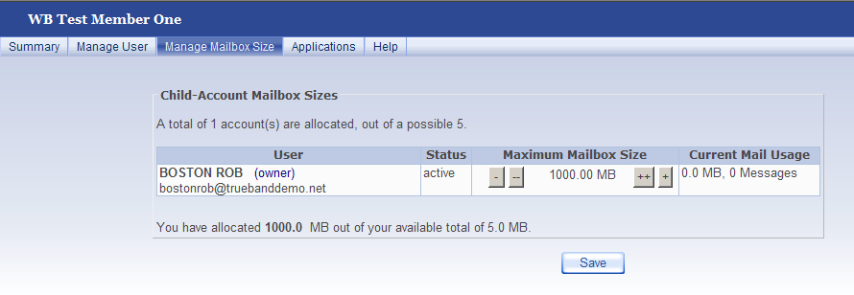
1

Choose Additional Applications
You may be able to purchase and download additional applications. View what’s available by clicking on the “Applications” tab.
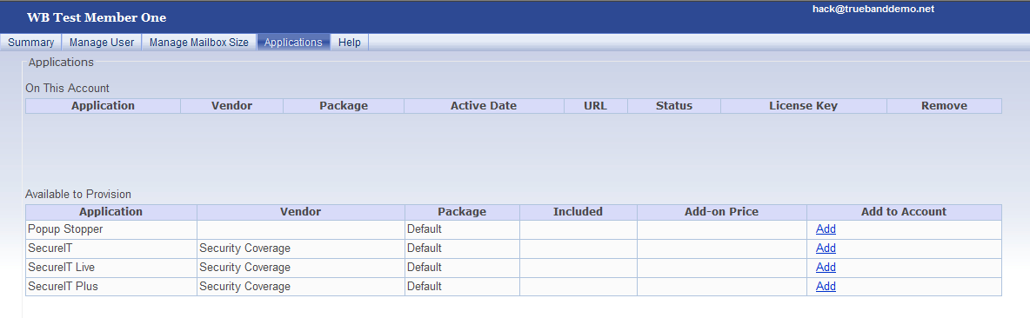
1
If you would like to buy and install Popup Stopper, for instance, click the “Add” link in the Popup Stopper row (Arrow #1).
Once you hit “Add,” you will see a screen similar to the one below. Click on the “Activate” link (Arrow #2) and you will receive directions for how to install the Popup Blocker and we will begin charging you for the application. If you have any questions about a particular application, please contact us!
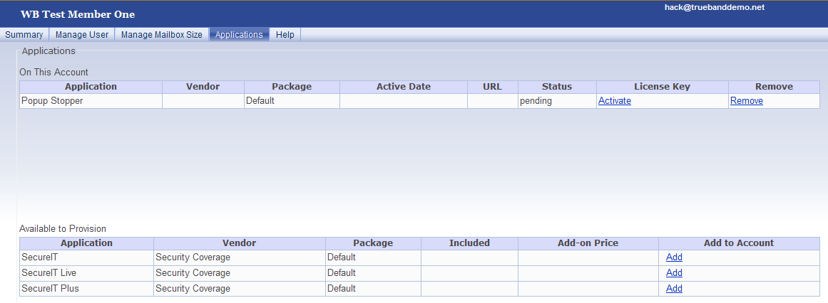
2

Add Additional Users
If you are the owner of the account, you can add up to four additional users (also called “child users”). You can also update their information at any time. Go to the “Manage User” tab and click on the icon with the person and plus sign (Arrow #1 below). After pressing on the icon, you will see something similar to the screen below.

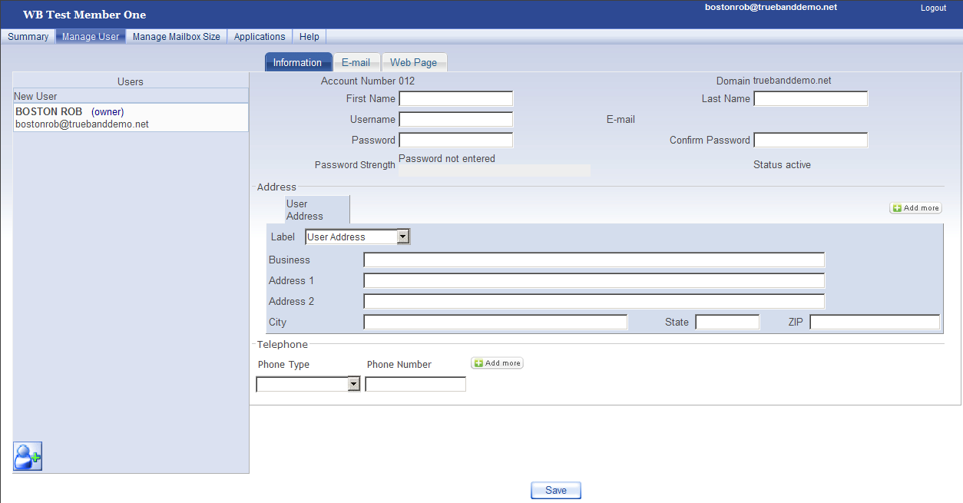
1
Fill out the information on each of the sub-tabs. In the example above, this includes the Information, E-mail and Web Page sub-tab screens.

Additional users can update much of their own information as well. When they log on, they will see a “Summary” tab and an “Edit” tab, instead of a “Summary” tab and a “Manage User” tab.

Set Mailbox Size for Additional Users
In addition to all the information that the owner of the account supplies for additional users under the “Manage User” tab, the owner of the account can determine the mailbox size for the additional users by going to the “Manage Mailbox Size” tab.

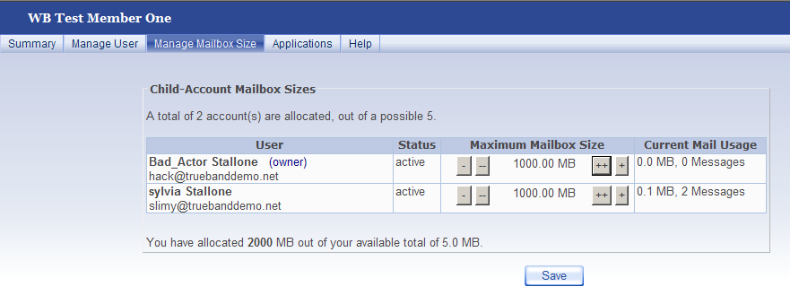
1

The status of user accounts can be "Active" or "Suspended" (Arrow #1). If the status is "Suspended," the user account is disabled. If you want to permanently remove a user from your account, you must contact us.

